Project Proposal: Multi-Agent Strategic Coordination in Slay the Spire2

1. Problem Description
Decision-making in uncertain environments often involves a tension between immediate objectives and long-term strategic goals. Optimizing for one dimension can easily create trade-offs, where short-term gains may come at the cost of future performance.
The video game Slay the Spire 2 provides a compelling setting to explore this challenge. To succeed, players must manage three interconnected layers of decision-making: tactical combat (turn-based survival), strategic deck-building (synergy optimization), and resource management (balancing HP and gold).We propose to model this process using a Multi-Agent System (MAS) framework. Instead of treating decision-making as a single unified process, we decompose it into specialized agents with different priorities. These agents must coordinate, and sometimes compete to produce an overall strategy that balances short-term survival with long-term growth.
2. Motivation
Slay the Spire 2 is a popular roguelike deck-building game with a lot of randomness and strategic depth. Players have to make decisions in a complex environment, balancing short-term survival with long-term planning. Although it is a single player game, the complexity of decision making makes it a good setting for modeling as a multi-agent system.
Decoupled Expertise:
The game requires multiple types of reasoning, from low-level calculations in combat to higher-level planning for deck synergy. Modeling these as separate agents enables a more modular and interpretable system.
Temporal Trade-offs:
Many decisions involve conflicts across time. For example, a “Combat Agent” may favor a high-damage card for immediate survival, while a “Strategic Agent” may reject it to maintain long-term deck quality. This creates a natural setting for studying coordination and negotiation between agents.
Dynamic Environment:
The game’s randomness structure prevents fixed strategies from working reliably. Agents must continuously adapt and update their decisions based on new information, reflecting challenges commonly seen in real-world decision-making systems.
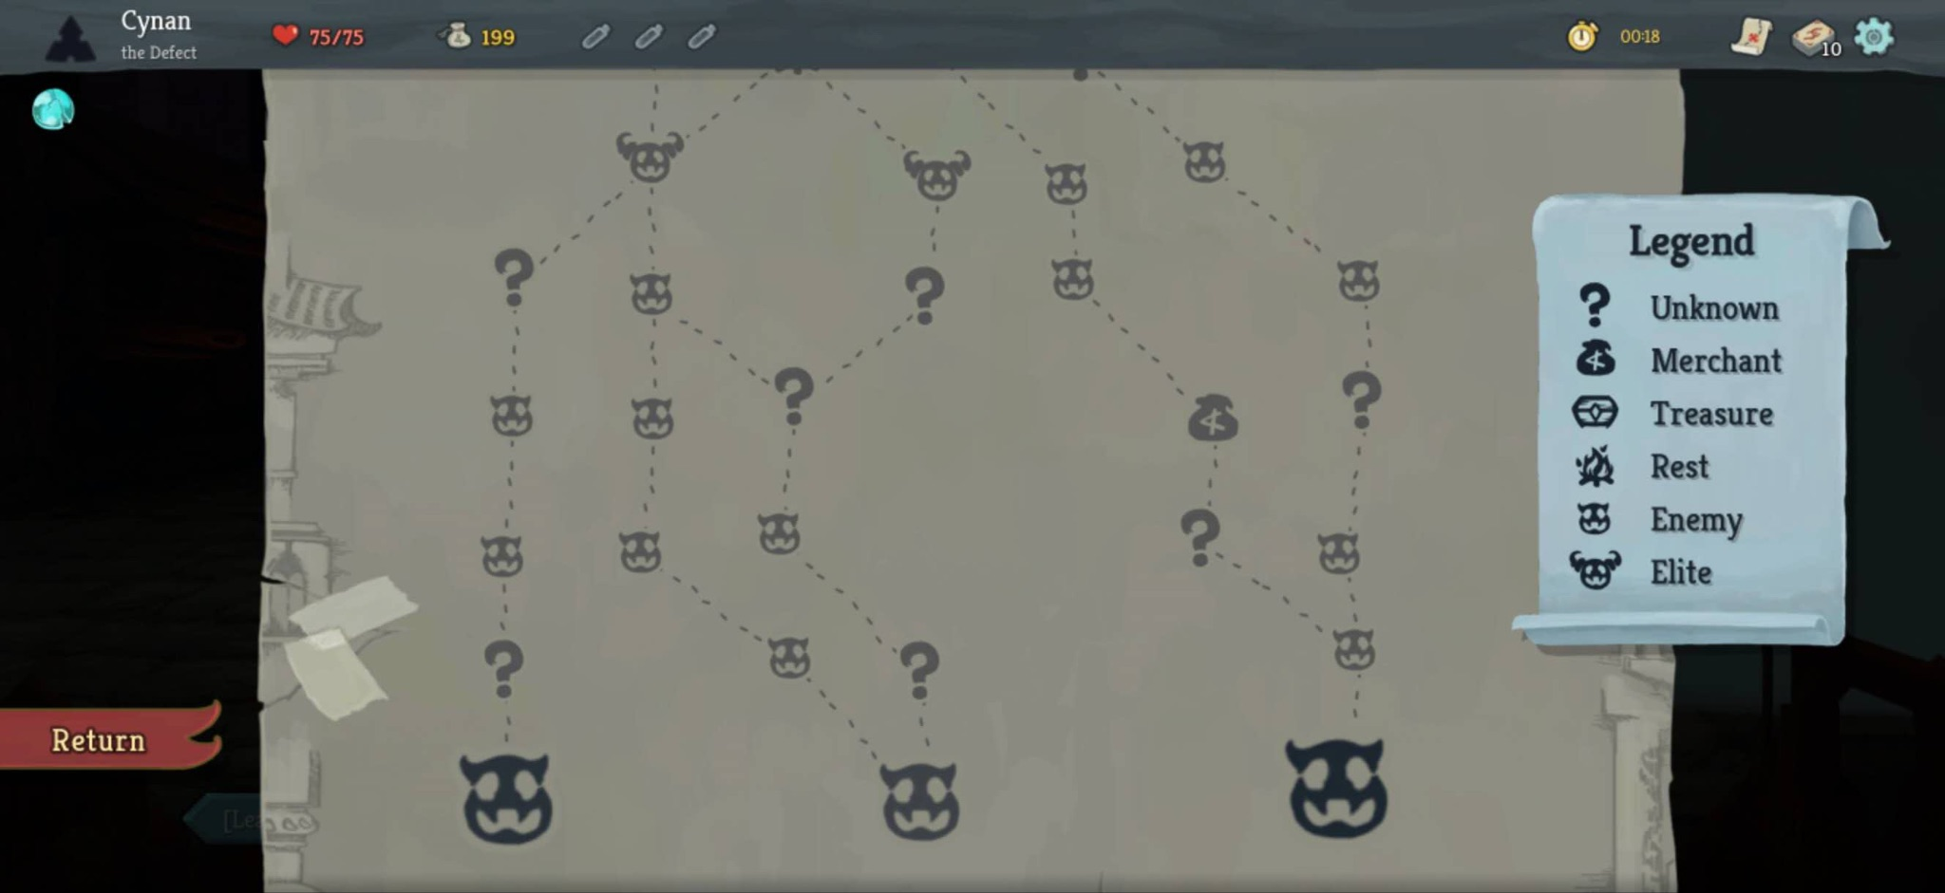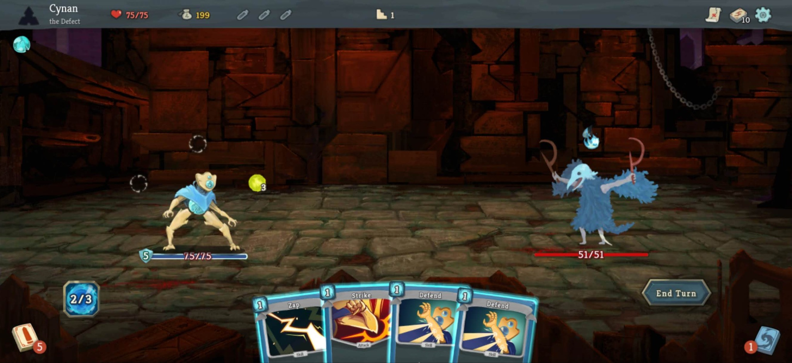
3. Initial System Idea
- Combat Agent:
Responsibility: Handles in-combat decision-making.
Goal: Maximize short-term survival and minimize HP loss.
Behavior: Its decision-making priority is to ensure the character's survival, opting to rest during critical moments.
- Strategic Agent:
Responsibility: Manages deck-building and long-term progression.
Goal: Maximize long-term deck strength and synergy.
Behavior: Its decision-making priority is to seek out more Elite battles.
- Economy Agent:
Responsibility: Manages gold and shop interactions.
Goal: Optimize resource efficiency and long-term value of gold.
Behavior: Its decision-making priority is to visit shops frequently to restock.
- Coordinator:
Responsibility: Aggregates and evaluates recommendations from all specialized agents.
Goal: Balance competing objectives to achieve the best overall outcome.
Behavior: Receives candidate actions or preferences from the Combat, Strategic, and Economy Agents, compares them based on the current game state, and selects the final action.

4. Planned Environment or Domain
We plan to use Slay the Spire 2 as the experimental environment. We leverage the STS2MCP framework, which exposes the game state and available actions through an API. This API acts as the interface for our LLM-based agents, allowing them to access game states and generate actions based on the current situation.

5. Team Members: Jibing Shi, Jiahui Xu

